Equipment Failure Analysis Report

TABLE OF CONTENTS
Contents
Abstract 2
Introduction 2
Biomedical Equipment 2
Smart Art 3
Bibliography 4

Abstract
Biomedical Engineering is an interdisciplinary field that combines principles of engineering with medical and biological sciences to improve healthcare.[1] It focuses on designing and developing medical devices, diagnostic equipment, and therapeutic technologies such as prosthetics, imaging systems, and monitoring instruments. [2] Biomedical engineers work on solving real-world medical problems using electronics, mechanics, computing, and material science. [3] The field plays a crucial role in advancing modern medicine, improving patient care, and enhancing the quality of life through innovative technological solutions. [4]
Biomedical engineering also plays a vital role in research and innovation, contributing to areas such as tissue engineering, biomaterials, artificial organs, and medical imaging.[5] Professionals in this field collaborate closely with doctors, researchers, and healthcare providers to translate scientific discoveries into practical medical solutions. [6] With the rise of artificial intelligence, robotics, and wearable health technologies, biomedical engineering continues to expand rapidly. As healthcare challenges grow worldwide, this field remains essential in developing safe, efficient, and accessible medical technologies for diverse populations.

Introduction

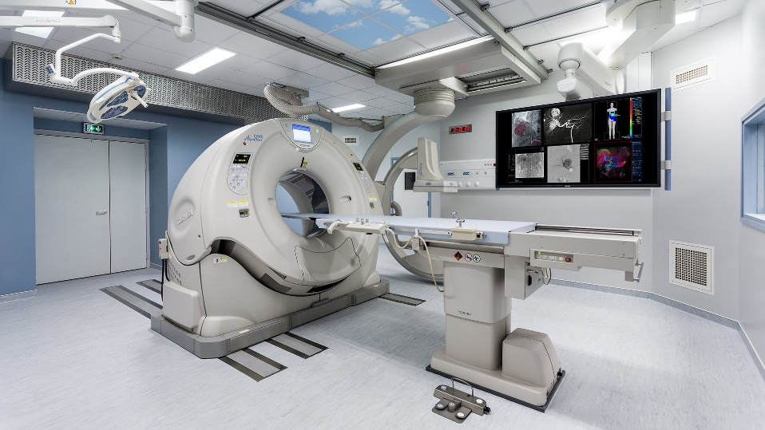
Biomedical Equipment
Figure 1: MRI
Equipment Name | Key Specification | Typical Clinical Use
ECG Machine | 12-lead, 0.05–150 Hz bandwidth | Monitoring heart electrical activity
Pulse Oximeter | SpO₂ range:70–100%, Accuracy ±2% | Measuring blood oxygen saturation
Infusion Pump | Flow rate: 0.1–1200 mL/hr | Controlled IV drug delivery
Defibrillator | Energy range: 1–360 Joules | Treating cardiac arrhythmias
Ultrasound Machine | Frequency:2–15 MHz probes | Diagnostic imaging

Smart Art

Bibliography

[1] | J. Bronzino, Introduction to Biomedical Engineering, Academic Press, 2012.
[2] | J. Semmlow, Signals and Systems for Bioengineers, Academic Press, 2018.
[3] | L. Cromwell, Biomedical Instrumentation and Measurements, Prentice Hall, 2011.
[4] | National Institutes of Health, "Biomedical Engineering Overview," U.S. Department of Health & Human Services, 2023. [Online]. Available: https://www.nih.gov.
[5] | E. Edelman, "Drug-Eluting Stents in Coronary Artery Disease," Annual Review of Medicine, vol. 57, no. 1, p. 199–210, 2006.
[6] | M. Gurcan, "Histopathological Image Analysis: A Review," IEEE Reviews in Biomedical Engineering, vol. 2, p. 147–171, 2009.

